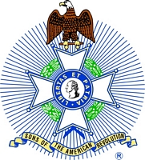

The kings mountain chapter, NC Society SAR
&
The Daniel morgan chapter, SC Society SAR
Invite you to attend the
235th anniversary of the battle of kings mountain

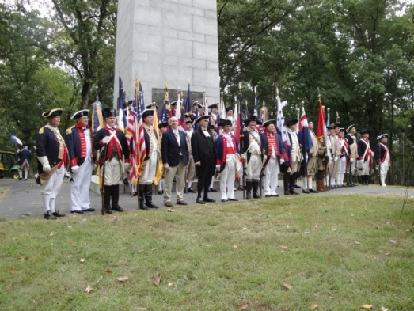

Wednesday, October 7, 2015 at 11:00 am
Kings Mountain National Military Park
Blacksburg, SC

SAR, DAR, C.A.R. and other patriotic and lineage societies and chapters are invited to participate in the formal wreath laying ceremony at the United States' Monument. Participants desiring to present a wreath must deliver it to the park's Visitor Center no later than 9:30 am on October 7th for labeling and transportation to the ceremony site. Ground transportation will be provided for those needing assistance to the ceremony site. Continental, militia or period attire is encouraged.

Please complete the registration form provided on the following page and return it no later than Saturday, September 26th for the registration to be included in the printed program. Registration forms should be returned to Doyle Campbell at either: 1407 Merrimount Ave, Kings Mountain, NC 28086 or doylecampbell@carolina.rr.com.

Questions about the event can be directed to either Doyle Campbell or Mark C Anthony (mcgt90@bellsouth.net).

The official hotel for the 2015 Kings Mountain anniversary is the Courtyard by Marriott located at 110 Mobile Dr, Spartanburg, SC 29303. A special room rate of $119.00 plus tax is available. Reservations can be made directly at the following link: Book your group rate for Kings Mountain Celebration - Spartanburg SC - October 6, 2015
The hotel can be reached at 864-585-2400. The deadline for making a reservation at this rate is September 8th. Additional hotels are available in Gaffney, SC, Gastonia, NC or Kings Mountain, NC.

Directions to Kings Mountain National Military Park (The park is located on South Carolina Highway 216):
- From Spartanburg, SC, take Interstate 85 NORTH to North Carolina Exit #2 and turn RIGHT. The Visitors Center is located approximately 5 miles on the left.
- From Charlotte, NC, take Interstate 85 SOUTH to North Carolina Exit #2 and turn LEFT. The Visitors Center is located approximately 5 miles on the left.
The following is a listing of the events associated with the anniversary commemoration.

Tuesday, October 6th
2:00 pm General James Williams Grave Marking
Cherokee County Administration Building, N Limestone St, Gaffney, SC
Sponsored by the General James Williams Chapter, SC Society SAR
Wreath registration contact: Charles McKinney Sr at cmckinneysr@yahoo.com or 864-833-4457
4:30 pm South Atlantic District, National Society SAR District Meeting
Courtyard by Marriott, 110 Mobile Dr, Spartanburg, SC
5:30 pm Kings Mountain Reception
Courtyard by Marriott, 110 Mobile Dr, Spartanburg, SC
6:00 pm The Night before Kings Mountain
Cowpens National Battlefield, 4001 Chesnee Hwy, Gaffney, SC 29341
Presented by the Overmountain Victory Trail Association

Wednesday, October 7th
9:30 am Deadline for delivery of wreaths to Kings Mountain Visitors Center
11:00 am Wreath Laying Ceremony at the United States Monument
3:00 pm Arrival of the Overmountain Victory Trail Marchers / Commemoration Ceremony

2015 Kings Mountain Wreath Registration

Registration forms should be returned to Doyle Campbell at either: 1407 Merrimount Ave, Kings Mountain, NC 28086 or doylecampbell@carolina.rr.com.

Deadline for registration so that it will appear in the printed program is Saturday, September 26th.

Society Name: ___________________________________________
Chapter Name: __________________________________________
Name of Presenter: __________________________________ Title: _________________________________
Wreath Dedicated to: ______________________________________

